**PHASE :5**

**Phase 5: Project Documentation & Submission**

**SUBMMITTED BY:**

**Name :Gajjala Harsha Kesava Reddy**

**Nm id:au723921244020**

**Gmail: harshagajjala122@gmail.com**

**Project Title: Real-Time Flood Monitoring and Early Warning System**

**1. Objectives:**

The primary objectives of this project are to:

* Deploy IoT sensors to monitor water levels in flood-prone areas.
* Develop a web-based platform to collect, analyze, and visualize real-time sensor data.
* Implement a flood warning system that issues alerts when flood risks are detected.
* Enhance public safety and emergency response coordination during flood events.

**2. IoT Sensor Deployment:**

**2.1 Sensor Selection:**

* Deploy a network of IoT sensors capable of measuring water levels in real-time. These sensors should have communication capabilities to transmit data to a central server.

**2.2 Sensor Placement:**

* Strategically place sensors in flood-prone areas, near rivers, streams, or locations with a history of flooding.
* Sensors are positioned at different heights to provide comprehensive data for flood prediction.

**2.3 Data Transmission:**

* Sensors communicate data to the central server using wireless protocols such as LoRa, Wi-Fi, or cellular connectivity.

**2.4 Diagrams and Schematics:**

* Include diagrams or schematics showing the sensor network layout, sensor placement, and communication infrastructure.

**3. Platform Development:**

**3.1 Back-End Development:**

* + - Create a back-end server using Python and Django to handle data ingestion and processing.
  + Set up a database (e.g., PostgreSQL) to store sensor data.
  + Implement data processing algorithms to validate and normalize incoming data.

**3.2 Front-End Development:**

* + Develop a user-friendly web platform using HTML, CSS, and JavaScript.
  + Design a dashboard to display real-time water level data, historical trends, and sensor locations on a map.
  + Implement a flood warning system that triggers alerts based on predefined criteria.

**3.3 Code Implementation:**

* + Share code snippets for key components, such as data processing and alerting logic.
  + Include screenshots of the web platform to illustrate the user interface and real-time data display.

**4. Impact on Public Safety and Emergency Response Coordination:**

The real-time flood monitoring and early warning system can significantly enhance public safety and emergency response coordination:

* -Timely Alerts: The system issues real-time alerts when water levels rise, enabling residents to take immediate action, such as evacuation or seeking shelter.
  + Data Accessibility: Public access to the platform empowers individuals to make informed decisions during flood events, contributing to their safety.
  + Emergency Services Coordination: Local emergency services can utilize the system to respond quickly and efficiently to flood-related incidents, potentially saving lives.
  + Data for Planning: Historical data collected by the system aids in flood management and infrastructure planning, leading to improved public safety in the long term.
  + Improved Communication: The platform facilitates effective communication between authorities and the public during flood events, ensuring that important information reaches those in affected areas.

By achieving its objectives and effectively utilizing IoT sensors, data processing, and the web-based platform, this system plays a crucial role in enhancing public safety and improving emergency response coordination during flood events.

he process of data preprocessing in sentiment analysis typically involves the following steps:

**Lowercasing:**

Converting all text to lowercase ensures uniformity and prevents duplication of words with different cases. For example, “Good” and “good” will be treated as the same word

**Tokenization:**

Breaking down the text into individual words or tokens is crucial for feature extraction. Tokenization divides the text into smaller units, making it easier for further analysis

**Removing punctuation**

: Punctuation marks like commas, periods, and exclamation marks do not contribute significantly to sentiment analysis and can be removed to reduce noise

**Stopword removal:**

Commonly occurring words like “the,” “and,” “is,” etc., known as stopwords, are removed as they add little value in determining the sentiment and can negatively affect accuracy.

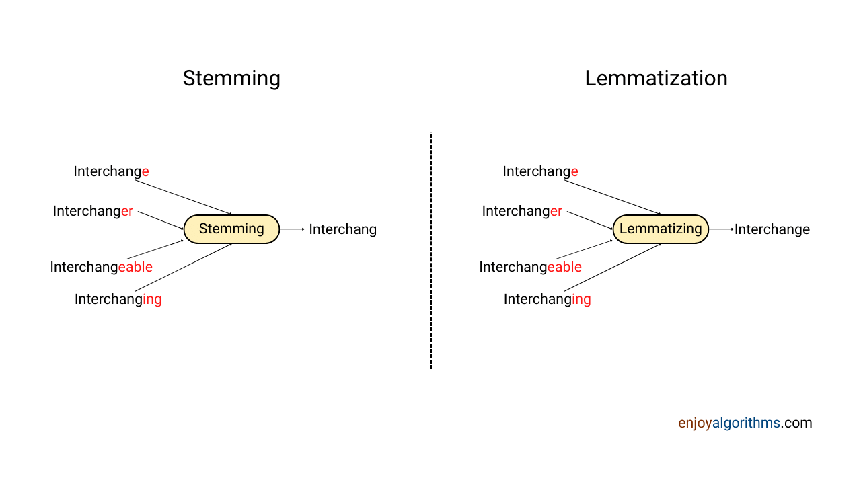

**Lemmatization or Stemming:**

Lemmatization reduces words to their base or root form, while stemming trims words to their base form by removing prefixes and suffixes. These techniques help to reduce the dimensionality of the feature space and improve classification efficiency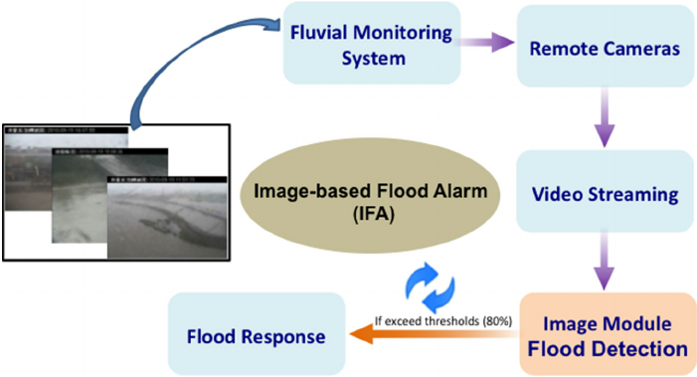

**Handling negations:**

Negations in text, like “not good” or “didn’t like,” can change the sentiment of the sentence. Properly handling negations is essential to ensure accurate sentiment analysis

**Handling intensifiers**:

Intensifiers, like “very,” “extremely,” or “highly,” modify the sentiment of a word. Handling these intensifiers appropriately can help in capturing the right sentiment

**Handling emojis and special characters:**

Emojis and special characters are common in text data, especially in social media. Processing these elements correctly is crucial for accurate sentiment analysis

**Handling rare or low-frequency words:**

Rare or low-frequency words may not contribute significantly to sentiment analysis and can be removed to simplify the model

**Vectorization:**

Converting processed text data into numerical vectors is necessary for machine learning algorithms to work. Techniques like Bag-of-Words (BoW) or TF-IDF are commonly used for this purpose.

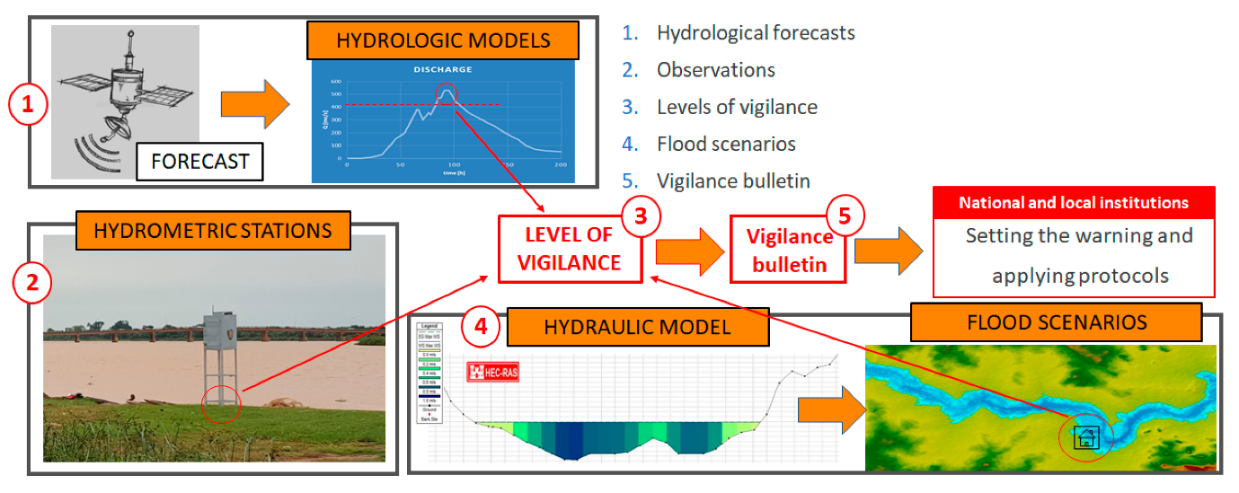

Real-time data. Rainfall estimates. Alert protocols. Everything comes together in our software platform. Built on open protocols, it works with whatever hardware you choose to use. More than 75% of all flood warning systems in the U.S. use our products or services.

A centralized data source facilitates the assessment of existing infrastructure for its resilience against flooding events. By analyzing the consolidated data, authorities can identify vulnerable areas and develop targeted rehabilitation plans. This approach ensures that limited resources are efficiently allocated to strengthen critical infrastructure, reducing the risk of damage during floods.

Consolidating weather and flood monitoring data into a single source also allows urban planners and designers to access accurate and comprehensive information. This enables them to make informed decisions when constructing or upgrading infrastructure, such as roads, bridges, and drainage systems. By incorporating reliable data, cities can better adapt to changing climate conditions and mitigate potential flood risks.